IntelliSQL: Intelligent SQL Querying with LLMs Using Gemini Pro
Project Documentation format
1. Introduction
• Project Title: IntelliSQL: Intelligent SQL Querying with LLMs Using Gemini Pro
• Team Members: Jitendra Reddy Tamma (Full Stack Developer & AI Integration) (Project Design, Backend Logic, Database Management, and UI Development)

2. Project Overview
• Purpose: To provide a seamless digital interface for non-technical users to interact with databases using natural language.
• Features:
- NLP Interface: Converts plain English into SQL commands via Gemini 1.5 Flash.
- Secure Access: Utilizes environment variables for API key masking.
- Live Data Preview: Displays database records in interactive tables.
- Error Handling: Implements Regex to clean AI responses for safe SQL execution.
3. Architecture
- Frontend:
• Built using Streamlit, which allows for rapid deployment of a data-driven web interface.
• The architecture is component-based, using a sidebar for multi-page navigation (Home, About, Query).

- Backend:
• Built with Python and the Google Generative AI SDK to handle LLM processing.
• Includes a logic layer that performs Regex-based sanitization to isolate raw SQL from AI responses.

- Database:
• Uses SQLite for lightweight, relational data storage (replacing MongoDB).
• The schema consists of a STUDENTS table with columns for NAME, CLASS, SECTION, MARKS, and COMPANY.
4. Setup Instructions
• Prerequisites:
- Python 3.9+
- Google Gemini API Key
- Pip (Python package manager)
• Installation:
- Clone the repository: git clone [GitHub-URL]
- Install dependencies: pip install streamlit google-generativeai python-dotenv
- Environment Variables: Create a .env file in the root directory and add GOOGLE_API_KEY="your_api_key_here".

5. Folder Structure
- Client:
- app.py: Main entry point containing the Streamlit UI and AI integration logic.
- readme.md: Local documentation providing instructions on how to interact with the user interface.
- requirements.txt: List of dependencies required for the client-side libraries, such as streamlit and google-generativeai.
- Server:
- .env: The server configuration file that securely stores the GOOGLE_API_KEY.
- sql.py: The backend database engineering script used to initialize the server-side database and seed it with initial data.
- data.db: The SQLite database file where the server stores and retrieves all relational records.
- .gitignore: Server-side configuration to ensure sensitive files like .env are not exposed to version control.
- pyvenv.cfg: Server configuration file that manages the Python environment version and paths.
6. Running the Application
Step 1: Database Setup:
Bash
python sql.py
``` [cite: 148]
Step 2: Start Application:
Bash
streamlit run app.py
``` [cite: 146]
App URL: The dashboard is accessible at http://localhost:8501

7. API Documentation
SQL Generation:
- Method: Internal POST to Gemini 1.5 Flash.
- Parameters: prompt_context, user_question.
- Response: A SQL string (e.g., SELECT * FROM STUDENTS;).
Database Execution:
- Function: read_query(sql, db).
- Parameters: Cleaned SQL string and database path.

8. Authentication
- API Authentication: Handled via API Key-based authentication using the Google Generative AI SDK.
- Security: Keys are stored in an encrypted/masked .env file and loaded into the environment at runtime using python-dotenv.
9. User Interface
- Registration/Login: Simplified via API key validation upon app startup.
- Query Interface: A professional text-input area where users type natural language questions.
- Data Visualization: Real-time rendering of results in interactive data tables.

10. Testing
- Strategy: Functional testing was performed on diverse natural language phrasings to ensure SQL accuracy.
- Tools: Manual UAT and Python Debugger were used to verify that Regex correctly strips AI conversational text.
11. Screenshots of project
GitHub Repository: https://github.com/TammaReddy123/IntelliSQL-Intelligent-SQL-Querying-with-LLMs-Using-Gemini-Pro-main

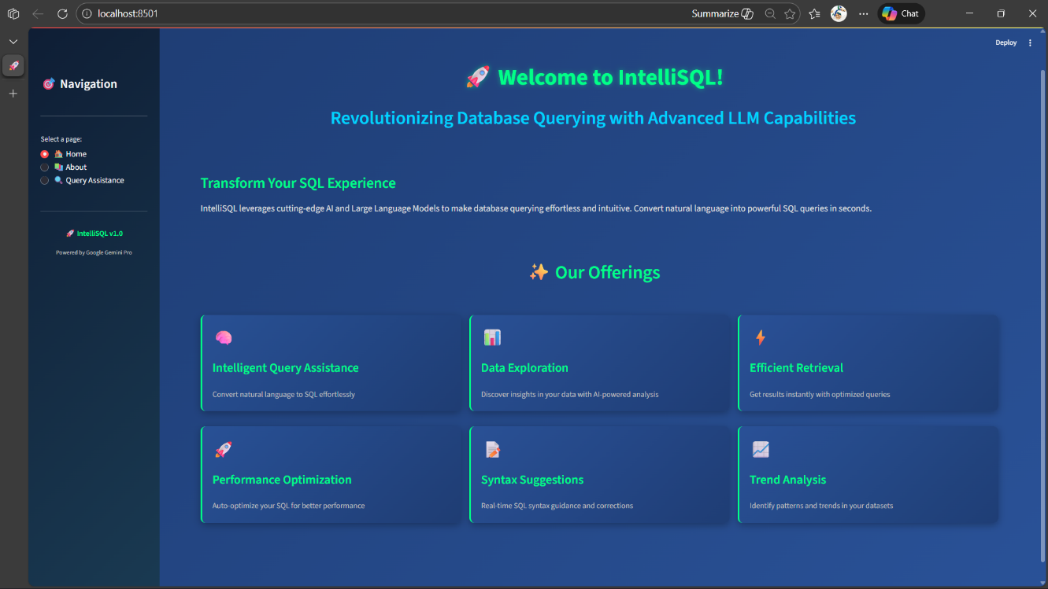

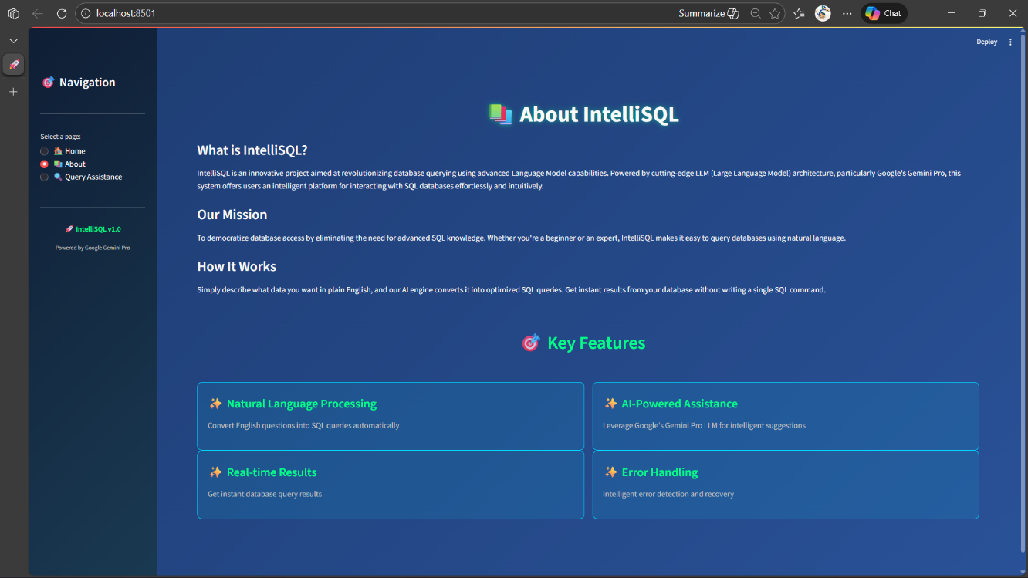
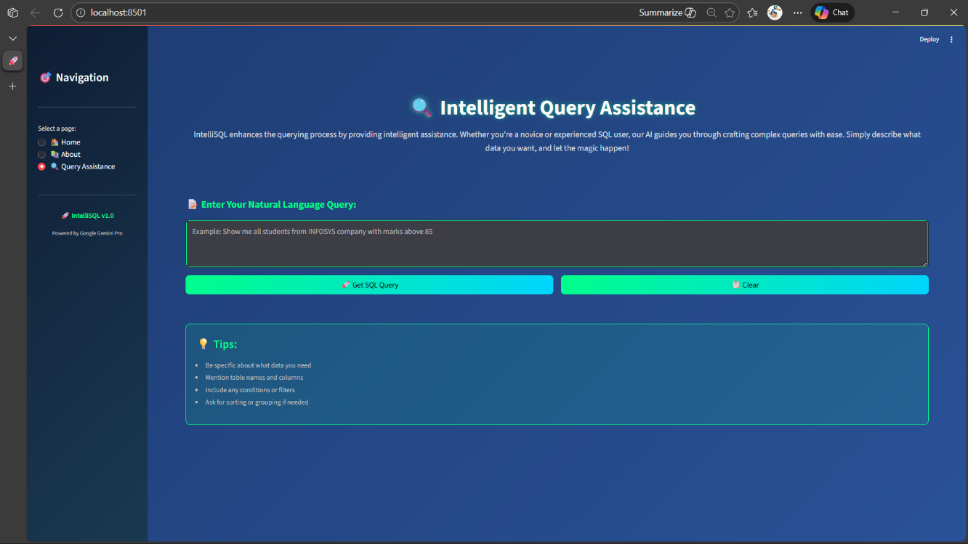

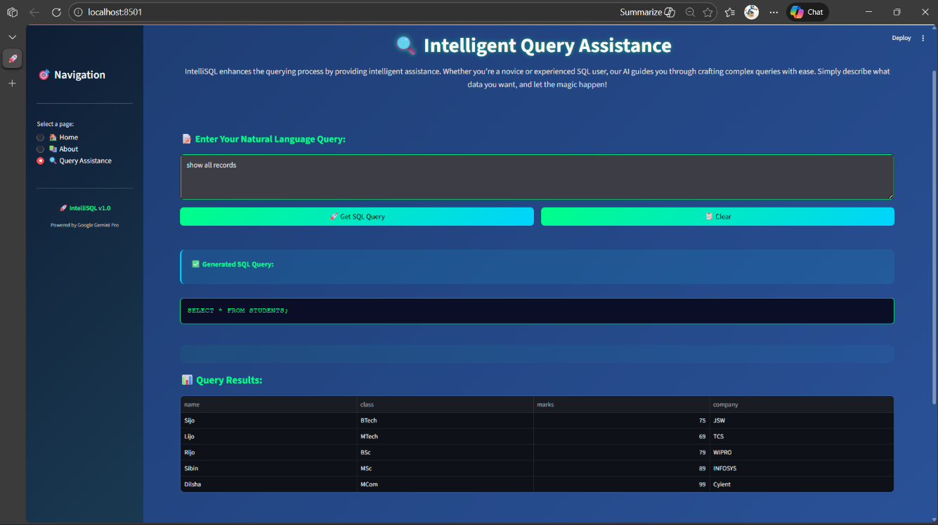

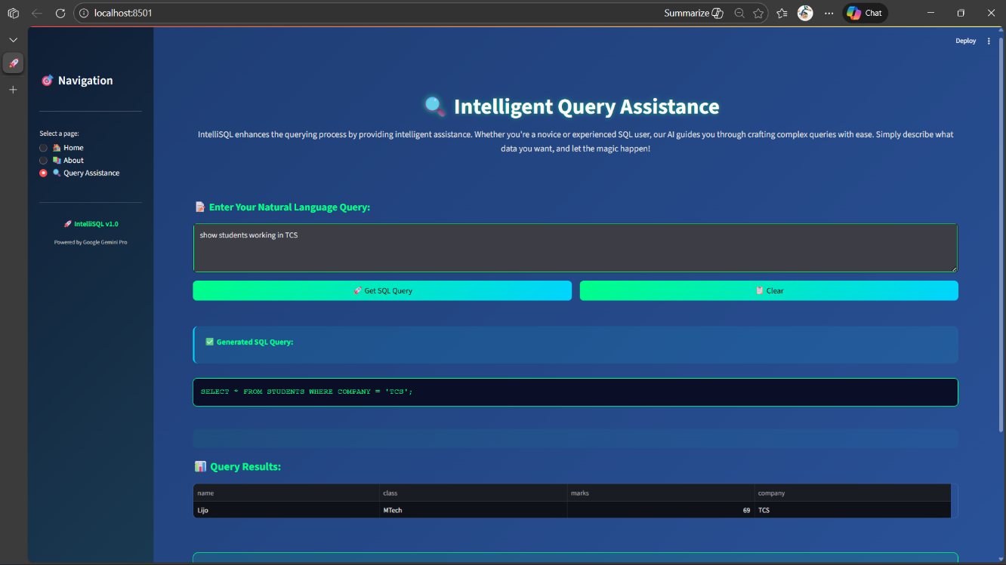

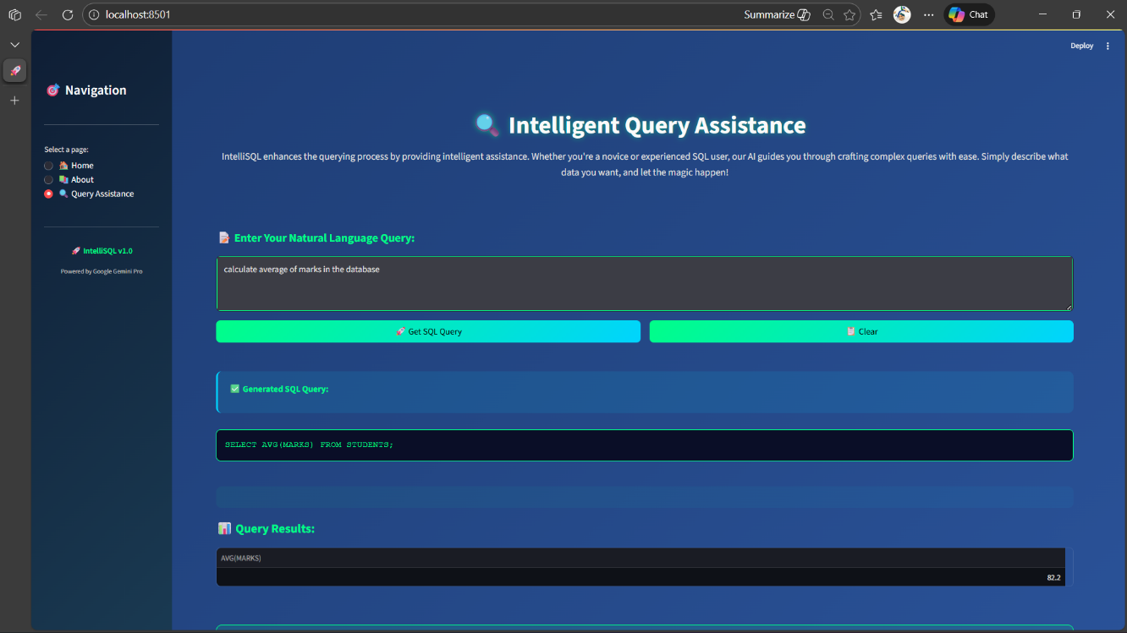

12. Known Issues
- Complex Joins: The current model may struggle with multi-table queries if the schema isn't explicitly defined in the prompt.
- Responsiveness: Wide data tables may require horizontal scrolling on smaller mobile displays.

13. Future Enhancements
- Voice-to-SQL: Integration of a microphone icon to allow users to speak their queries.
- AI Insights: Using the AI to explain the data results in plain English below the table.
- Multi-DB Support: Adding connectors for PostgreSQL and MySQL.

